IFRS 9 – Forward Looking Integration in the Expected Credit Loss

Version 0.00

|  |  |  |  |
| --- | --- | --- | --- |
| Version | Created / Modified by | Modifications | Date |
| 0.0 | Ismail Boutaleb | Initialisation | 17/01/2018 |
| 1.0 | Arnaud Jousseaume  (Prestataire)  Ismail Boutaleb | The matrix distance used for the optimization in part II.c has been changed. The study justifying this model change is available in part III.f.  Added an alternative choice for the optimization routine.  The methodology to mix default vector and migration vector (part II.d) is now justified in part III.g.  Part II.e: added a footnote to explain the extrapolation difference between IFRS 9 and EBA Stress tests.  Part III.d.1, added logit transformation among modeling choices | 29/10/2018 |

Table of contents

I. Purpose of this document 4

II. Forward Looking PD Model design 5

a. 1 Year Default Probability 5

b. Rating Migration modeling 5

c. Retrieving the economic indicator 6

d. Mixing default and migration models 6

e. Forward Looking term structure default probability 7

III. Alternative approaches and justification of assumptions 8

a. Model sectorial segmentation 8

b. Default and migration segmentation 9

c. Rating segmentation 10

d. Systemic indicator 11

1. Default indicator 11

2. Migration indicator 11

e. Correlation fitting 14

f. Impact of the norm in Z Migration Computation 14

1. Presentation of the different norms studied 15

➢ Distances found in the literature 15

➢ Norms found in the literature 16

➢ Weighted norms 16

2. Impact of the norm choice on historical migration systemic inicator 16

3. Inversion of the norm 17

➢ First approach 17

➢ Second approach 18

4. Replication 18

➢ Downgrade and Upgrades 18

➢ 2 years marginal default rate 19

5. Sensitivity on a few observation 20

6. Conclusion 21

g. Impact of the normalization method when mixing default and migration models 21

h. Lags of systemic indicators within the regression 22

IV. Forward Looking LGD 22

a. Correlation calibration 22

b. Term structure conditional LGD 23

V. Results 24

a. Default probability term structure 24

b. LGD term structure 25

VI. Multiple scenarios calculation 26

VII. Bibliography 27

# Purpose of this document

The purpose of this document is to describe the integration of forward looking to PD and LGD ECL parameters. First the design of the forward looking default probability term structure, alternative approaches and justification. Then the forward Looking LGD Hillebrand model is described. Results illustrations are given afterwards. Finally, it describes Credit Agricole Group approach to the multiple scenarios IFRS 9 requirements.

# Forward Looking PD Model design

The purpose of this section is to describe the overall modeling of a migration matrix. A 2 factor approach is used in order to separate the default and the migration events. It has been demonstrated empirically that these two events behave differently.

The large corporate population is segmented through Corporate and Financial Institutions, the modeling follows the same principle for both segments.

Given the following observable parameters:

* Historical global TTC default rate; global means aggregated above all ratings
* Historical global PIT default rate
* Historical TTC migration matrix (this matrix is not directly observable, it is obtained through a regularization process described in the Migration Matrix construction documentation)
* Historical PIT migration matrices

We aim at retrieving historical systemic factors for default and migration and for each segment. These historical factors levels are correlated to the macroeconomic variables set and projected through a satellite model described in the “Projection Model Documentation”. Once the systemic factors projected, this document also explains how they are transformed into forward looking migration matrices and default probability curves.

## 1 Year Default Probability

A Merton model is used to retrieve the historical PIT systemic default variable $Z^{D}$ following the formula

$$Z_{t}^{D}= \frac{N^{-1}(\overline{DR})}{\sqrt{r}}-\frac{\sqrt{1-r}}{\sqrt{r}}N^{-1}({DR}_{t})$$

Where:

* $Z_{t}^{D}$ is the value of the PIT default systemic factor on date $t$
* $\overline{DR}$ the global TTC default rate; global means all ratings aggregated
* $r$ is a correlation parameter. It is set using the Basel formula.
* $N^{-1}$ is the inverse of the cumulative Gaussian distribution function
* $DR_{t}$ is the PIT global default rates

This systemic variable is assumed to be common to all ratings. The historical observations are correlated to historical observations of macroeconomic variables and projected to obtain Forward Looking estimations. Then, given a $\hat{Z^{D}}$ projection, a default vector is obtained by the following Merton model formula for each rating $i$.

$$PD_{t}^{i}=N\left(\frac{N^{-1}\left({\overline{DR}}^{i}\right)-\sqrt{r}.\hat{Z_{t}^{D}}}{\sqrt{1-r}}\right)$$

* $PD_{t}^{i}$ is the model default probability of rating $i$ on date $t$

## Rating Migration modeling

Given a migration systemic variable $Z_{t}^{M}$, the following process is used to retrieve a model migration matrix.

Denote:

* $M_{i,j}$ the coordinates of the model migration matrix
* $M\left(Z_{t}^{M}\right)$ the model migration matrix
* $\overline{M_{i,j}}$ the TTC migration matrix. The following process allows retrieving the model migration matrix
* $n$ the default index

Migration matrix construction process:

* For each $i$:

 $M_{i,n}=N\left(\frac{N^{-1}\left(\overline{M_{i,n}}\right)-\sqrt{r}.\hat{Z_{t}^{M}}}{\sqrt{1-r}}\right)$

 + For each $j$:
$$M_{i,j}= N\left(\frac{N^{-1}\left(\sum_{k=j}^{n}{\overline{M_{i,k}}}\right)-\sqrt{r}.\hat{Z_{t}^{M}}}{\sqrt{1-r}}\right)-\sum_{k=j+1}^{n}{M_{i,k}}$$

* The default is assumed to be an absorbing state

$M_{n,j}=0, for each j<n$

$M_{n,n}=1$

## Retrieving the economic indicator

The $Z^{M}$ variable is not directly observable; the process described in b is reversed through optimization on closeness to the PIT historical observed matrices $M_{t}^{PIT}$ in order to obtain the historical PIT migration systemic variable.

For each $t$ in the observable past generations

$$Z_{t}^{M}≔ arg\min_{Z}\left\|M\left(Z\right)-M_{t}^{PIT}\right\|$$

Where:

* $\left\|M\right\|$ is the “*weighted MDEX norm”* defined as
$$\left\|A-B\right\|= \frac{1}{N²}\sum_{i=1}^{N}{\sum_{j=1}^{N}{w_{i} sign(i-j)(A_{i,j}-B_{i,j})}}$$

* $N$ is the number of row of the matrix
* $w_{i}$ is the number of observations on the row $i$ of the PIT matrix

Note that, given two matrices $A$ and $B$, $\left\|A-B\right\|=0$ implies that $A=B$.

The choice of this definition of distance between modeled and observed matrix upon other existing distances is justified by quantitative studies described in part III.f.

Optimization routine

The Broyden-Fletcher-Goldfarb-Shanno algorithm is used. Multiple runs of the algorithm are performed starting from different initial $Z^{M}$ levels. The global minimum is retained.

This alternative choice has been tested, it is faster and leads to the same result: The global minimum is researched by a process of two iterations:

1. Testing all possible values of $\left\|M\left(Z\right)-M_{t}^{PIT}\right\|$ for $Z$ ranging from -3 to +3 with a step of 0.1. The minimum argument is found and denoted ${ Z}^{*1}$.
2. Testing all possible values of $\left\|M\left(Z\right)-M_{t}^{PIT}\right\|$ for $Z$ ranging from $Z^{*1}-0.1$ to $Z^{*1}+0.1$ with a step of 0.01. The minimum argument is found and denoted ${ Z}^{*}$.

## Mixing default and migration models

The systemic factor $Z_{t}$ is the key variable that summarizes the macroeconomic scenario. Since defaults are factual and migrations are mostly based on expert judgments sustained by forward looking information, we might assume a different dynamics of the dependence on the scenario.

Thus the transitions to non-defaulted states and the probabilities of default are computed separately.

The model used is based on mixing the modeled default vector using the default systemic variable and the modeled migration matrix using the migration systemic variable. To ensure that the model matrix is still a transition matrix (row sums = 1), the diagonal is adjusted.

## Forward Looking term structure default probability

The process above describes the way to retrieve a model migration matrix for 1Y transitions.

The transitions are supposed to follow a non-homogeneous Markov Chain behavior. This assumption implies that the 2year migration matrix is the multiplication of the 1st and the 2nd 1 year matrices. As a whole, the $t$-th cumulated migration matrix is the product of all 1 year migration matrices $M_{1}$, …, $M_{t}$.

For each projected couple $\left(Z_{t}^{D}, Z_{t}^{M}\right)$ a 1Y model migration matrix is obtained. The forward looking macroeconomic scenarios allow for 3 years projection. From the 4th year and above, an average behavior is assumed leading to the use of the 1Y TTC migration matrix. [1]

The term default probability of rating $i$ is given by the $n^{th}$ column of the $T$ years cumulated migration matrix. See V.a section for an illustration.

# Alternative approaches and justification of assumptions

## Model sectorial segmentation

The model is segmented based on sectorial criteria through Corporate and Financial Institutions. This choice is supported by the following arguments:

* TTC matrices are inputs to the model and are segmented through Corporate and Financial Institutions.
* Historical observations suggest different behaviors for corporate and FI defaults and migration

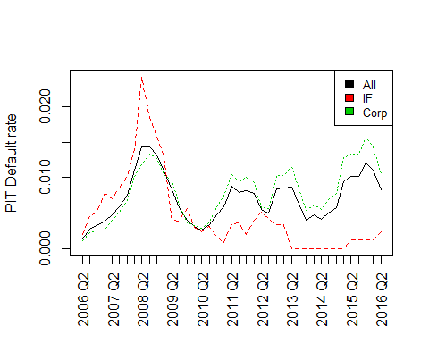

Figure 1: PIT historical observed default rate. Note different dynamics between corporate and financial institutions.

* Deeper segmentation using geographical area is not used because of the lack of data. Investment grade (IG) vs. non-investment grade (NIG) countries segmentation was tested, the number of observations is too poor to be used in the model. For example, the matrices below show the TTC FI NIG and TTC Corp NIG transitions matrices. Note the number of cells with no observations highlighted in orange.





* CACIB clients are large corporate and financial institutions which are majorly not present in a single country.

## Default and migration segmentation

A different model design has been tested. It consists in using a unique systemic indicator for default and migration in contrast with the mixing between a migration systemic indicator and a default systemic indicator used. Separating migration and default modeling is supported by the following arguments:

* Factual versus judgmental phenomenon: Default is factual whereas migration is obtained through the rating process which is based on quantitative metrics, qualitative reasoning and judgments.
* References from the literature suggest a separation between the modeling of both dynamics. See [1].
* Historical observations (see Figure 2 Figure 3) show different behavior between default and migration

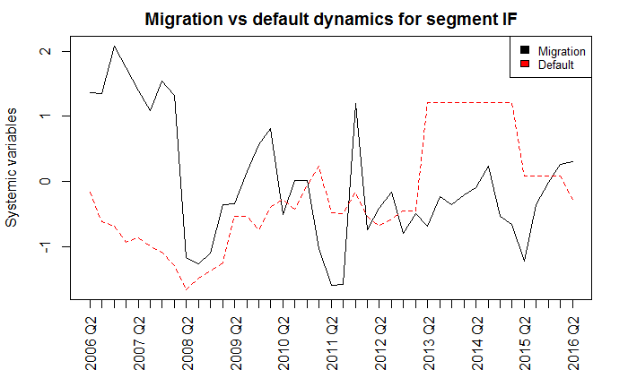

Figure 2: Systemic variables for default and migration for financial institutions. Note that both dynamics are not identical. This supports the need to a separate modeling.

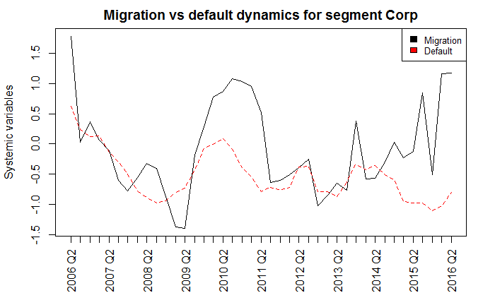

Figure 3: Systemic variables for default and migration for corporates. Note that both dynamics are not identical. This supports the need to a separate modeling.

## Rating segmentation

Additional segmentation using a different systemic variable depending on the rating is being studied. The data observed for each rating does not allow for calibrating a stable systemic variable specific to each rating, however some groupings using proximity (A+ and A for example) and similar historical behavior could lead to more observations and a stable calibration.

A study is being made to assess the relevance of this approach for a future development.

## Systemic indicator

The systemic variable serves as an indicator for the position in the macroeconomic cycle. The model in use assumes a definition for this variable but alternative metrics could be used too.

### Default indicator

For the default indicator three metrics have been tested, the PIT default rate and Merton systemic variables (in use). All three are mapped to each other through closed formula. Merton systemic variable is used mainly for dispatching a global prediction to a rating specific prediction.

* PIT default rate
  + Pros: observable
  + Cons: the variable’s distribution is not suitable for linear regression; projection distribution truncation using floors to avoid negative values introduces bias in the model.
* Merton systemic variable (in use)
  + Pros: Assimilated to a Gaussian distribution and therefore suitable to linear regression; It allows for dispatching the prediction to rating specific default rates; Default and systemic indicators have the same interpretation; the correlation parameter could allow for more precise segmentation in the future.
  + Cons: the historical observation is obtained using a non-observable parameter: the correlation.
* Logit transformation:
  + Pros: Suitable to linear regression;
  + Cons: Does not allow for dispatching default rates from a global predicted default rate to a rating specific default rate

### Migration indicator

The migration indicator could be assessed using three different metrics:

1. Systemic variable is defined above and is the indicator in use.
2. Systemic variable obtained through a combination between the best and worst historical observation weighted using the default rate. This approach is proposed by Autorité de Contrôle Prudentiel Banque de France, see [2]. It is mainly based on the following formula $\hat{Z_{t}^{migrations}}= λ_{t}Z_{crisis}+\left(1-λ_{t}\right)Z_{expansion}$  where:

$Z_{crisis}$ and $Z_{expansion}$ are systemic variables retrieved from a crisis migration matrix and an expansion migration matrix and ;

$λ$ is given by a positioning in the macroeconomic cycle using the default rate

$$λ_{t}= \frac{{\hat{DR}}_{t}-{DR}_{expansion}}{DR_{crisis}-{DR}_{expansion}}$$

This approach has been rejected for the following arguments:

* + It has already been demonstrated in section III.b that default rate is not a relevant indicator for migration dynamics
  + It has been tested by CACIB but led to inconsistencies when defining the crisis and expansion period as the worst period for migration does not correspond to the worst period for default. For example, Figure 2 shows that the worst period for default is 2018 Q2 to Q4 whereas the worst period for migration is 2011 Q2 to Q3. This obviously introduces inconsistency when defining $DR_{crisis}$ and $Z_{crisis}$ added to model instability due to the possibility that $Z_{crisis}$ could be superior to $Z_{expansion}$.
  + This approach has been adapted by CACIB and gave rise to the use of a migration metric instead of the default rate described in the following.

1. Systemic variable obtained through a combination between the best and worst historical observation weighted using the second largest eigenvalue. The second largest eigenvalue is deemed in the literature as a migration intensity indicator (see [3], [4] and [5] where the migration indicator is called “rating mobility indicator”). Furthermore, historical evidences could be observed in Figure 4 on both S&P and internal databases. This alternative approach was tested by CACIB but rejected for its performance in replicating historical observed migration matrices.

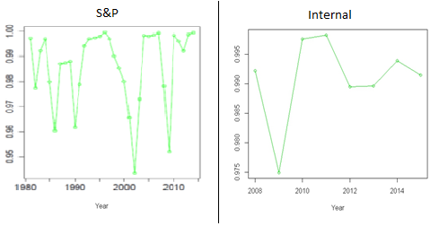

Figure 4: Second largest eigenvalues of historical migration matrices. Database S&P to the left and Internal to the right. Historical crises are emphasized, which support the relevance of the second largest eigenvalue as a migration indicator.

The choice between approach 1 and 3 has been made using a backtesting which consists on replicating historical observed PIT matrices using historical PIT model matrices. Several distance indicators between both matrices are computed (See Figure 5, Figure 6 for results). The indicators are defined below; they are also used for measuring the impact of matrix regularization (See [5]). Detailed use of the indicators is documented in the matrix construction and regularization note.

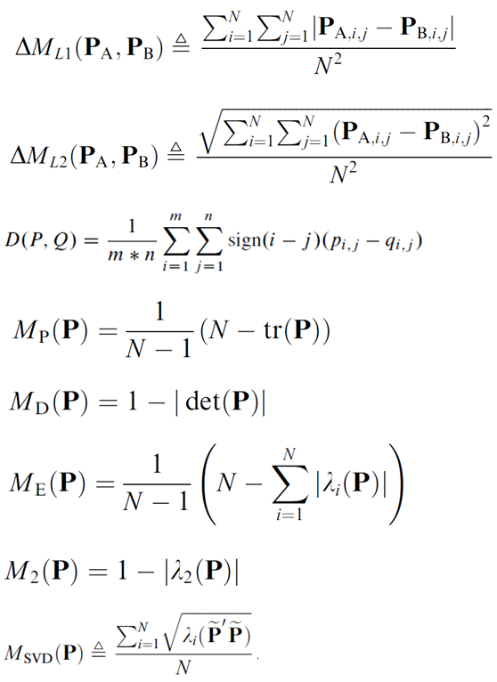

Measures based on matrix eigenvalues

Distances between 2 matrices

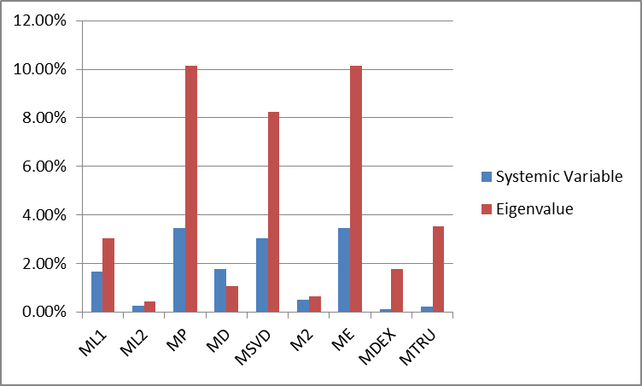

Figure 5: Average gap between observed matrices and model matrices, all generations and segments combined. Note that most indicators (all unless MD) suggest better replication for using the systemic variable

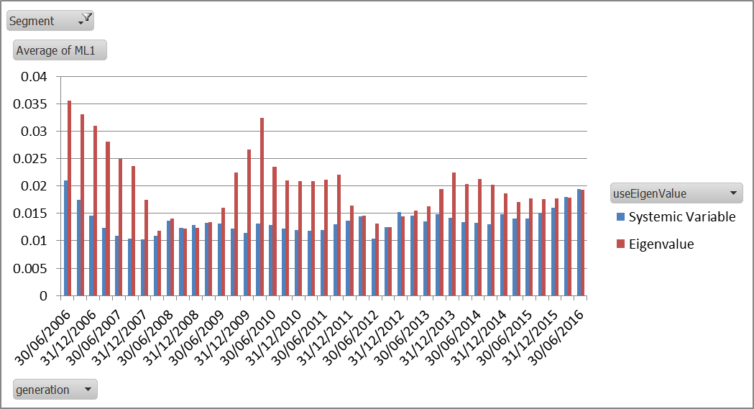

Figure 6: Average gap between observed matrices and model matrices using ML1 indicator and on Corporate segment. Note that using Systemic Variable leads to better replication of historical matrices for all generations

## Correlation fitting

The model is dependent on the correlation parameter which is not directly observable. Two different approaches were tested and a Basel correlation approach is in use.

* Basel correlation: In its 2005 publication, the Basel Committee released its estimation formula for corporate and financial institutions asset correlations. (See [6]).
  + The formula gives a correlation for each PD level

|  |  |
| --- | --- |
| Corporate | Financial institutions |
| $$r_{i}=0.12\frac{1-e^{-50{PD}_{i}}}{1-e^{-50}}+0.24\frac{e^{-50{PD}_{i}}}{1-e^{-50}}$$ | $$r_{i}=0.15\frac{1-e^{-50{PD}_{i}}}{1-e^{-50}}+0.30\frac{e^{-50{PD}_{i}}}{1-e^{-50}}$$ |

* Historical correlation: This is a moment matching based calibration on default rate historical observations. It results to extremely low correlation levels (see Table 1), which limits the model sensitivity.
* Likelihood optimization: An alternative approach consisting on a likelihood optimization is in study.

|  |  |  |  |
| --- | --- | --- | --- |
|  | **Basel correlation** | **Historic correlation** | **Historic Correlation 75%** |
| **Financial Institutions** | 27% | 19% | 22% |
| **Corporate** | 21% | 4% | 5% |

Table 1: Correlation levels using basel correlation or historic correlation based on moment matching calibration. The historic correlation 75% column is a conservative estimation using a 75% percentile.

## Impact of the norm in Z Migration Computation

Contrary to the Z Default formula, the Z Migration formula is not invertible and it is necessary to use the following optimization to compute historical Z Migration:

For each $t$ in the observable past generations

$$Z_{t}^{M}≔ arg\min_{Z}\left\|M\left(Z\right)-M_{t}^{PIT}\right\|$$

Where $\left\|M\right\|$ is a matrix norm and $M(Z)$ is the model matrix for a given Z.

As presented in part 1, several norm choices are available in the literature. As shown in part b, the choice of the norm in the optimization has an impact on both stability and level of Z Migration.

Given the impact of the norm on the Z Migration historic, it is necessary to define proprieties that a norm should fulfil given the situation (having a good representation of the PIT matrices). Three kinds of proprieties are tested: reversibility, replication and sensitivity to a few numbers of observations.

* Reversibility:
  + It is expected for a norm to be invertible: $arg\min_{Z}\left\|M\left(Z\right)-M\left(Z_{1}\right)\right\|=Z_{1}$. All the norms tested passed this test (c.1).
  + A second test is then implemented: the implied $Z$ of the matrix mean of $M(Z_{1})$ and $M(Z_{2})$ is expected to be between $Z_{1}$ and $Z_{2}$ (c.2): $arg\min_{Z}\left\|M\left(Z\right)-\frac{M\left(Z_{1}\right)+M\left(Z_{2}\right)}{2}\right\|∈[Z_{1};Z_{2}]$.
* Replication: downgrade and upgrade rates or default rates (part 4) modeled should be close to the ones of the PIT matrix. Norms have different performances on those replication tests which are then good selections criteria.
* Sensitivity: the Z Migration calculated should not be largely sensitive to a few observations. Indeed, a single observation should not have much impact on the Z level. To ensure that this propriety is verified, the impact on the Z optimization of a random cutoff of 5 % of the matrix observations is compute (part 5).

The following table presents the results of the different test:

|  |  |  |  |  |  |  |  |  |  |  |  |  |
| --- | --- | --- | --- | --- | --- | --- | --- | --- | --- | --- | --- | --- |
| Norms  Tests | ML1 | ML2 | MDEX | MTRU | ME | M2 | MSVD | Norm  Euc | MTRU  weight | MDEX  weight | ML1  weight | ML2  weight |
| Invertibility (c) | OK | OK | OK | OK | OK | OK | OK | OK | OK | OK | OK | OK |
| Invertibility 2 (c) | OK | OK | OK | OK | KO | OK | KO | OK | OK | OK | OK | OK |
| Upgrades (d.1) | Good | Interm | Best | Interm | Bad | Bad | Bad | Interm | Good | Good | Interm | Interm |
| Downgrades (d.1) | Interm | Interm | Good | Interm | Bad | Bad | Bad | Bad | Good | Best | Interm | Interm |
| 2Y default rate (d.2) | Interm | Interm | Good | Best | Bad | Bad | Bad | Interm | Good | Good | Interm | Interm |
| Consistency (e) | Interm | Interm | Good | Good | Bad | Bad | Bad | Bad | Good | Best | Interm | Interm |

Given those results, the norm $MDEX_{w}$ (cf part 1) is chosen by MQP.

### Presentation of the different norms studied

This analysis has been realized on the same norm previously used by CACIB for the regularization of the TTC migration matrix. Weighted norms are also tested to ensure that the Z Migration computation is not sensitive to few observations on a given rating.

##### Distances found in the literature

$$∆M_{L1}(P_{A},P_{B})= \frac{1}{N^{2}}\sum_{i=1}^{N}{\sum_{j=1}^{N}{|\left(P_{A,i,j}-P_{B,i,j}\right)}}|$$

$$∆M_{L2}(P_{A},P_{B})= \frac{1}{N^{2}}\sqrt{\sum_{i=1}^{N}{\sum_{j=1}^{N}{\left(P_{A,i,j}-P_{B,i,j}\right)}}²}$$

$$∆M_{DEX}\left(P_{A},P_{B}\right)= \frac{1}{N^{2}}\sum_{i=1}^{N}{\sum_{j=1}^{N}{sign\left(i-j\right)\left(P_{A,i,j}-P_{B,i,j}\right)}}$$

$$∆M_{TRU}\left(P_{A},P_{B}\right)= \frac{1}{N^{2}}\sum_{i=1}^{N}{\sum_{j=1}^{N}{\left(i-j\right)\left(P_{A,i,j}-P_{B,i,j}\right)}}$$

$$M_{EUC}\left(P_{A}, P_{B}\right)=\sqrt{\max\left(SP\left({\left(P_{A}-P_{B}\right)}^{'}.\left(P_{A}-P_{B}\right)\right)\right)}$$

##### Norms found in the literature

These indicators are found in the literature as measures of a standalone migration matrix. In order to use them as a distance, a difference is used.

$$M_{P}(P)= \frac{1}{N-1}\left(N-tr\left(P\right)\right)$$

$$M_{D}\left(P\right)= 1-|det⁡(P)|$$

$$M_{E}(P)= \frac{1}{N-1}\left(N-\sum_{i=1}^{N}{\left|λ_{i}\left(P\right)\right|}\right)$$

$$M_{2}\left(P\right)= 1-|λ_{2}\left(P\right)|)$$

$$M_{SVD}(P)= \frac{1}{N}\sum_{i=1}^{N}{\sqrt{λ_{i}\left(\tilde{P}'\tilde{P}\right)}}$$

##### Weighted norms

To ensure that the Z computed is sensitive to few observations and enhance the measure robustness; the contribution of each row is weighted by the number of observation on the row of the PIT matrix.

$$∆M_{L1_weighted}(P_{A},P_{B})= \frac{1}{N^{2}}\sum_{i=1}^{N}{\sum_{j=1}^{N}{w_{i}|(P_{A,i,j}-P_{B,i,j})}}|$$

$$∆M_{L2_weighted}(P_{A},P_{B})= \frac{1}{N^{2}}\sqrt{\sum_{i=1}^{N}{\sum_{j=1}^{N}{\left(w_{i}P_{A,i,j}-{w_{i}P}_{B,i,j}\right)}}²}$$

$$∆M_{DEX_weighted}(P_{A},P_{B})= \frac{1}{N²}\sum_{i=1}^{N}{\sum_{j=1}^{N}{w_{i} sign(i-j)(P_{A,i,j}-P_{B,i,j})}}$$

$$∆M_{TRU_weighted}(P_{A},P_{B})= \frac{1}{N²}\sum_{i=1}^{N}{\sum_{j=1}^{N}{w_{i}(i-j)(P_{A,i,j}-P_{B,i,j})}}$$

### Impact of the norm choice on historical migration systemic inicator

The choice of the norm is determinant for the computation of the historical $Z_{Mig}$. Indeed, for the same set of PIT matrices, there is significant variation in the implied migration indicator $Z_{Mig}$ (Cf. Figure 7 vs. Figure 8). In addition, choosing an inadequate norm implies undesirable $Z_{Mig}$ volatility (Cf. Figure 8).

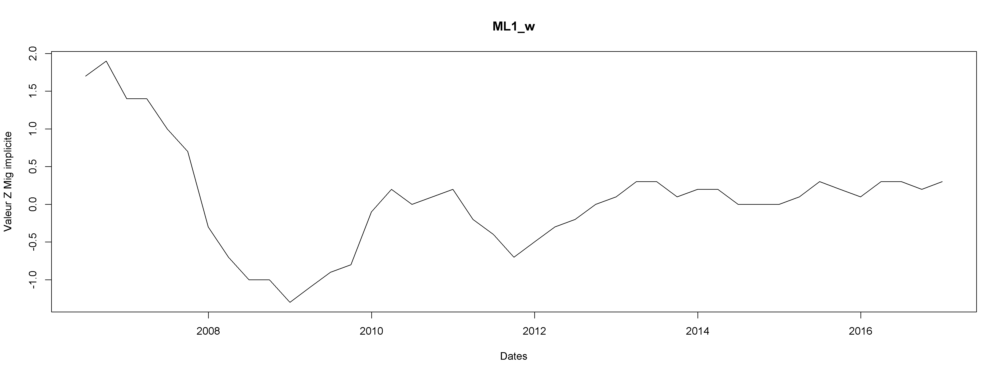

Figure 7: Example of Z Migration implied using ML1_w norm. Financial Institutions – Historiacal Internal Data

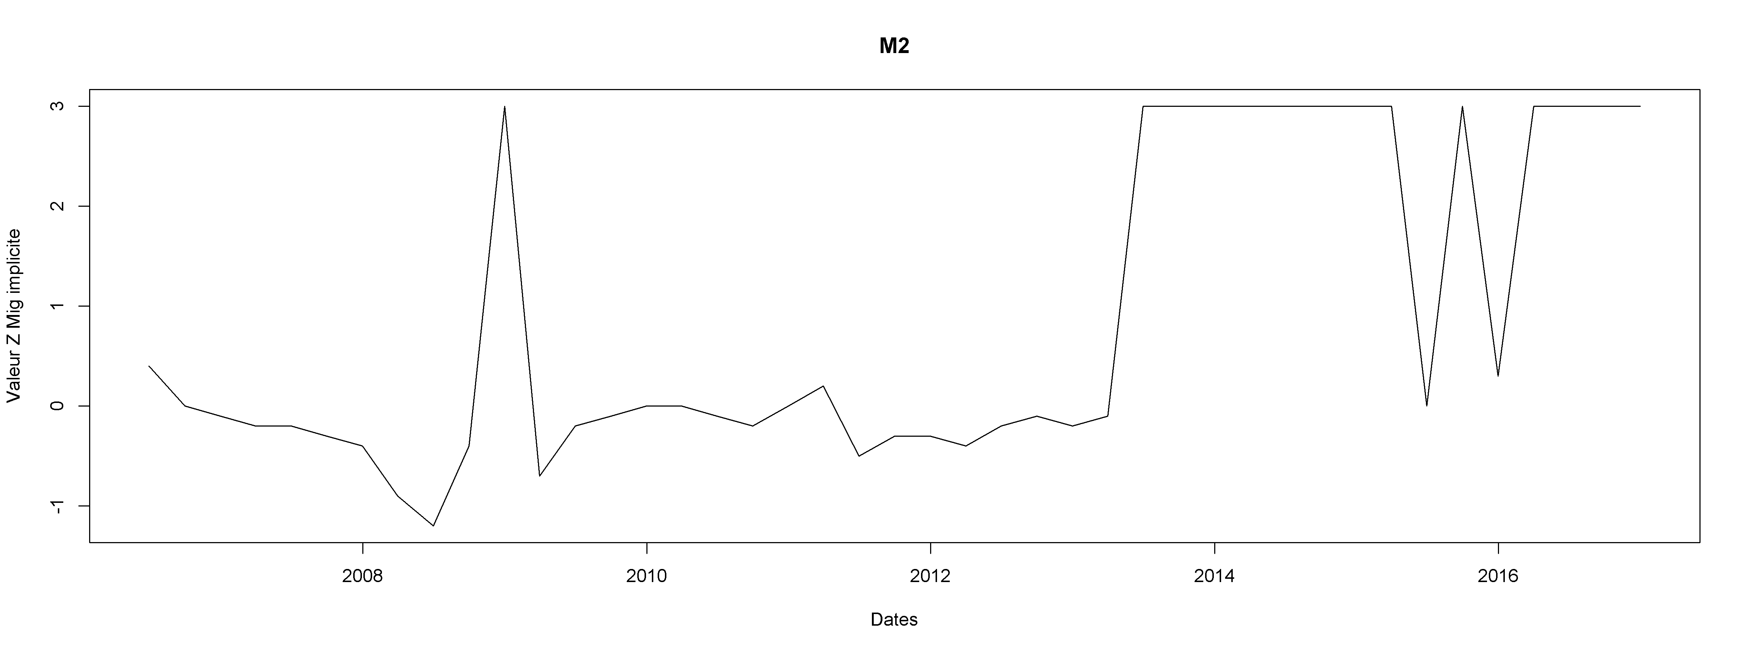

Figure 8: Example of Z Migration implied using $M2$ norm. Financial Institutions – Historiacal Internal Data

Those graphs are available for each norm and each segment (Corp/IF) in the following document.



Given those differences, the choice of the norm is determinant. A set of test for each norm is presented in the following sections.

### Inversion of the norm

Given that there is no real PIT matrix in this section, the notion of weighted matrix doesn’t make sense here. The weighted norms and the corresponding non-weighted norms share identical results.

##### First approach

A first test to asses that the norm fits its expected proprieties is the reversibility of the norm. It is expected that $arg\min_{Z}\left\|M\left(Z\right)-M\left(Z_{1}\right)\right\|=Z_{1}$.

This is tested for a set of $Z_{1}$ values ranging from -3 to 3 with a 0.1 step to explore multiple probable as well as extreme conditions.

All of the norms pass this test.

##### Second approach

A second test of reversibility is then implemented: the implied $Z$ of the matrix is expected to be between $Z_{1}$ and $Z_{2}$ (b.2):

$$arg\min_{Z}\left\|M\left(Z\right)-\frac{M\left(Z_{1}\right)+M\left(Z_{2}\right)}{2}\right\|∈[Z_{1};Z_{2}]$$

The results of this test are presented in the attached document. The norms passing this test are: ML1, ML2, MDEX, MTRU (both weighted or not) and NormEuc.



### Replication

The norm will be adapted to the situation if the Matrix Model arising from the Z Migration has the same characteristics than the initial PIT matrix. The two characteristics tested will be the downgrade and upgrade rates and the two years default rate.

##### Downgrade and Upgrades

The model matrix should have upgrades and downgrades rates close to upgrades and downgrades rates of the PIT matrix. This test is performed for each norm:

* For each generation and each norm, the Z Migration is compute
* For each generation and each norm, the model matrix associated with the Z Migration is compute
* Downgrades and upgrades rates are calculated for each Model matrix and each intial PIT matrix
* Global rates are compared

The global result of this study is presented in the following table.

|  |  |  |  |  |
| --- | --- | --- | --- | --- |
|  | **Corporates** | | **IF** | |
|  | **Global Down** | **Global Up** | **Global Down** | **Global Up** |
| **ML1** | 2,40% | 2,50% | 3,00% | 2,20% |
| **ML2** | 2,40% | 2,40% | 3,20% | 2,90% |
| **MP** | 11,60% | 11,70% | 10,30% | 10,80% |
| **ME** | 11,60% | 11,70% | 10,30% | 10,80% |
| **M2** | 4,20% | 4,20% | 5,60% | 22,40% |
| **MSVD** | 10,70% | 10,80% | 7,50% | 8,20% |
| **MDEX** | 2,40% | 2,50% | 2,10% | 2,90% |
| **MTRU** | 2,50% | 2,50% | 2,60% | 2,80% |
| **NormEuc** | 3,80% | 4,10% | 6,00% | 5,90% |
| **ML1_w** | 3,00% | 3,10% | 3,20% | 3,20% |
| **ML2_w** | 3,30% | 3,40% | 3,30% | 3,90% |
| **MDEX_w** | 2,30% | 2,40% | 2,00% | 3,70% |
| **MTRU_w** | 2,30% | 2,40% | 2,10% | 4,40% |

Note For the reader: for Corporates, the average difference in absolute value between the global downgrade rates of the PIT matrix and the one of the optimized matrix obtained with ML1 is 2,1%.

The best norms on this criterion are then MDEX, MDEX_w and MTRU_w.

The following document contains the data leading to the previous table.



##### 2 years marginal default rate

The 2 years marginal default rate is the default rate resulting from the one year migration matrix:

$$\left(\begin{matrix}(A+,A+) & ⋯ & (A+,E-) \\ ⋮ & ⋱ & ⋮ \\ (A+,E-) & ⋯ & (E-,E-)\end{matrix}\right)\left(Vector of DefaultRate TTC\right)$$

Note that the 2Y marginal default rate is chosen over the 2Y cumulated default rate, because the first depends only on $Z_{mig}$ whereas the last depends on $Z_{mig}$ and $Z_{D}$. The 2Y marginal default measure being a pure consequence of $Z_{mig}$ is an indicator of the $Z_{mig}$ impact.

It is expected for this 2 years marginal default rate from PIT matrix to be close from the one for Model matrix. Those rates have been calculated for each generation an each norm. The following table shows the average difference by generation between those two rates. The first column is a difference rating by rating[2] and the second column a difference of the sum of the default rating for all ratings[3].

|  |  |  |  |  |
| --- | --- | --- | --- | --- |
|  | **IF** | | **Corporates** | |
|  | **Average difference by rating** | **Global average difference** | **Average difference by rating** | **Global average difference** |
| **ML1** | 0.0022% | 0,00087% | 0,0021% | 0,0105% |
| **ML2** | 0.0024% | 0,00105% | 0,0024% | 0,0132% |
| **MP** | 0.0036% | 0,00265% | 0,0034% | 0,0317% |
| **ME** | 0.0116% | 0,00876% | 0,0034% | 0,0317% |
| **M2** | 0.0036% | 0,00265% | 0,0057% | 0,0622% |
| **MSVD** | 0.0056% | 0,00469% | 0,0032% | 0,0293% |
| **MDEX** | 0.0032% | 0,00229% | 0,0021% | 0,0065% |
| **MTRU** | 0.0021% | 0,00048% | 0,0020% | 0,0051% |
| **Euc** | 0.0021% | 0,00038% | 0,0031% | 0,0258% |
| **ML1_w** | 0.0030% | 0,00192% | 0,0022% | 0,0136% |
| **ML2_w** | 0.0022% | 0,00110% | 0,0022% | 0,0144% |
| **MDEX_w** | 0.0023% | 0,00121% | 0,0021% | 0,0088% |
| **MTRU_w** | 0.0021% | 0,00068% | 0,0021% | 0,0080% |

Note For the reader: for Corporates, the average of absolute difference by rating and generation between 2 years default rate modeled and PIT is 0.0022% for the norm ML1. The Global average of absolute difference by generation is 0.0113%.

The following documents contains the data leading to the previous table.



The best norms on this criterion are then: ML1, ML2, MDEX, MTRU (weighted or not).

### Sensitivity on a few observation

**A norm should not lead to high sensitive Z Migration to adding or removing few observations.**

To ensure this condition, the Z Migration is recalculated based on a new matrix lacking 5% of the observations. Observations are randomly deleted and for each generation, 100 randomly transformed matrices are calculated. The more remote the original and recalculated Z Migration are the higher is the sensitivity.

To randomize the transformation, the following process is adopted:

1. Initially, the transformed matrix is equal to the PIT matrix containing all the observation
2. Picking a random number between 1 and the total number of observations on the transformed matrix
3. Deleting the observation corresponding to this random number
4. Restarting the process at step 2. while 5% of initial number of observation have not been deleted
5. The Z Migration of the transformed matrix is then computed for each norm

This procedure is run for all PIT matrices (all generations x segments). Two metrics are computed to evaluate the performance of the norm:

* The average variance of the difference between the simulations and the initial value of Z for all the generations
* The average absolute difference between a simulation and the initial value of Z for all the generations

The following table summarizes the results:

|  |  |  |  |  |
| --- | --- | --- | --- | --- |
|  | **Corporates** | | **IF** | |
|  | **Average variance of difference** | **Average absolute difference** | **Average variance of difference** | **Average absolute difference** |
| **ML1** | 0,0016 | 0,0020 | 0,0022 | 0,0026 |
| **ML2** | 0,0015 | 0,0029 | 0,0029 | 0,0032 |
| **MP** | 2,0023 | 0,0965 | 1,8332 | 0,0914 |
| **ME** | 2,0023 | 0,0965 | 1,8332 | 0,0914 |
| **M2** | 0,0016 | 0,0050 | 0,0759 | 0,0177 |
| **MSVD** | 2,3987 | 0,1056 | 1,9125 | 0,0932 |
| **MDEX** | 0,0006 | 0,0013 | 0,0014 | 0,0020 |
| **MTRU** | 0,0011 | 0,0018 | 0,0019 | 0,0025 |
| **Euc** | 0,0074 | 0,0069 | 0,0864 | 0,0088 |
| **ML1_w** | 0,0017 | 0,0024 | 0,0023 | 0,0036 |
| **ML2_w** | 0,0010 | 0,0017 | 0,0088 | 0,0034 |
| **MDEX_w** | 0,0006 | 0,0010 | 0,0008 | 0,0246 |
| **MTRU_w** | 0,0007 | 0,0013 | 0,0011 | 0,0301 |

Note for the reader: For Corporates, the average variance of the difference between the simulations and the initial value of Z for all the generations is 0.00161 for ML1. The average of absolute difference is 0.02619.

The following documents contain the data leading to the previous table.



### Conclusion

**Given the results of all the studies carried out, the norm $MDEX_{w}$ is chosen by MQP.**

## Impact of the normalization method when mixing default and migration models

This section aims to justify the approach of applying on diagonal the difference between the default vector and the default column of the migration matrix.

The sum of each line has to be equal to 1. This is not the case initially given that default rate and migrations rates are obtain by two different ways. CACIB has studied different repartition methods of the difference between 1 and the sum of the transition matrix line (this difference is named $ε_{i}$ for line $i$ and could be positive or negative):

* The « diagonal » method, which corresponds to the current methodology. The value $ε_{i}$ is added to the diagonal of line $i$
* The « Bad Ratings » method: corresponds to an uniform repartition of $ε_{i}$ degradation rates of line $i$ (All columns $j$ for $j≥i$)
* The « Uniform » method, which corresponds to an uniform repartition of $ε_{i}$ on all the line $i$

The provision has been calculated for those three methodologies. Those are the results for Corporates and FI.

|  |  |  |  |  |  |
| --- | --- | --- | --- | --- | --- |
| Simulation | Simulation Description | Segment | EAD_Moteur | ECL_COMPOSE | FLL_ECL |
| 394 | Diagonal | Corp | 174 196 373 101 | 388 079 605 | 844 010 322 |
| 398 | Bad Ratings | Corp | 174 196 373 101 | 384 355 251 | 850 329 723 |
| 399 | Uniform | Corp | 174 196 373 101 | 397 005 811 | 835 952 723 |
| 394 | Diagonal | IF | 189 434 755 904 | 55 608 935 | 58 777 653 |
| 398 | Bad Ratings | IF | 189 434 755 904 | 56 143 813 | 59 305 061 |
| 399 | Uniform | IF | 189 434 755 904 | 56 213 051 | 59 367 014 |

Table 2: Simulation of the 31/05/18 ecl calculated with different aggregation methods

Using more favorable repartition (Uniform) or more conservative repartition (Bad Ratings) leads to less than 10 M€ movement in the ECL.

The choice of repartition method is not significant.

## Lags of systemic indicators within the regression

In the current modelling, there is no lag of Z Migration and Z Default models. The integration of lags has been tested, ie $Z_{t}=a+bZ_{t-1}+cX_{t}$ where $X_{t}$ stands for the other macroeconomics variables.

The exact same process is then applied with this new explanatory variable of $Z_{t}$.

For all models (Z Migration and Z Default) on both perimeters (Corporates and Financial Institutions), there is no week learners selected with a non-null stacking weight selected.

Given that adding a lag within the modelling causes a loss of four observations and that it leads to no model selected with this new variable, this modelling has not been retained.

# Forward Looking LGD

The calculation of Expected Credit Loss under IFRS 9 requires a forward looking LGD term structure.

The purpose of this section is to describe the integration of forward looking scenarios in the unsecured LGD.

Unsecured LGD is already segmented in the Basel methodology thorough Corporate, Banks, Insurance, Funds and Sovereign. Regulatory LGD minus downturn margins is used as the starting point. It is considered as a TTC LGD.

Whereas dependent corporate unsecured LGD is modeled using Hillebrand model, no statistical model is applied to the other segments, the TTC LGD is used.

## Correlation calibration

The calibration used for IFRS 9 framework is common to the Economic Capital measurement. Here attached is the documentation.



The Basel internal model calibration of TTC corporate unsecured LGD is given in Table 2. These are the downturn LGD minus the downturn margins.

|  |  |  |  |
| --- | --- | --- | --- |
| **Zone** | **CA** | **Filiere** | **LGD** |
| **Zone 1 Secured** | **<300M€** | **LGD Faible** | 27% |
| **Zone 1 Secured** | **<300M€** | **Autre** | 27% |
| **Zone 1 Secured** | **<300M€** | **LGD Fort** | 27% |
| **Zone 1 Secured** | **>300M€** | **LGD Faible** | 27% |
| **Zone 1 Secured** | **>300M€** | **Autre** | 27% |
| **Zone 1 Secured** | **>300M€** | **LGD Fort** | 27% |
| **Zone 1** | **<300M€** | **LGD Faible** | 31% |
| **Zone 1** | **<300M€** | **Autre** | 40% |
| **Zone 1** | **<300M€** | **LGD Fort** | 45% |
| **Zone 1** | **>300M€** | **LGD Faible** | 31% |
| **Zone 1** | **>300M€** | **Autre** | 31% |
| **Zone 1** | **>300M€** | **LGD Fort** | 45% |
| **Zone 2** | **<300M€** | **LGD Faible** | 40% |
| **Zone 2** | **<300M€** | **Autre** | 48% |
| **Zone 2** | **<300M€** | **LGD Fort** | 50% |
| **Zone 2** | **>300M€** | **LGD Faible** | 40% |
| **Zone 2** | **>300M€** | **Autre** | 40% |
| **Zone 2** | **>300M€** | **LGD Fort** | 50% |
| **Zone 3** | **<300M€** | **LGD Faible** | 42% |
| **Zone 3** | **<300M€** | **Autre** | 54% |
| **Zone 3** | **<300M€** | **LGD Fort** | 58% |
| **Zone 3** | **>300M€** | **LGD Faible** | 42% |
| **Zone 3** | **>300M€** | **Autre** | 42% |
| **Zone 3** | **>300M€** | **LGD Fort** | 58% |
| **Zone 4** | **<300M€** | **LGD Faible** | 59% |
| **Zone 4** | **<300M€** | **Autre** | 59% |
| **Zone 4** | **<300M€** | **LGD Fort** | 59% |
| **Zone 4** | **>300M€** | **LGD Faible** | 59% |
| **Zone 4** | **>300M€** | **Autre** | 59% |
| **Zone 4** | **>300M€** | **LGD Fort** | 59% |
| **Zone 5** | **<300M€** | **LGD Faible** | 78% |
| **Zone 5** | **<300M€** | **Autre** | 78% |
| **Zone 5** | **<300M€** | **LGD Fort** | 78% |
| **Zone 5** | **>300M€** | **LGD Faible** | 78% |
| **Zone 5** | **>300M€** | **Autre** | 78% |
| **Zone 5** | **>300M€** | **LGD Fort** | 78% |

Table 3: Corporate unsecured LGD TTC for internal regulatory model

The correlation parameters’ calibration is not adapted for each segment due to the lack of data. However, the $a$ parameter is adjusted for each segment using the following formula:

$$a_{segment}=N^{-1}\left(LGD_{segment}\right)*\sqrt{1+b^{2}}$$

The Hillebrand $a$ parameter is interpreted as a cursor of the model unconditional average LGD. Therefore, adjusting $a$ to each segment allows the of the model unconditional average LGD to match the TTC LGD.

## Term structure conditional LGD

The conditional LGD is given by $$E\left[LGD∕Z^{D}\right]= Φ\left(\frac{a-bdZ^{D}}{\sqrt{1+b^{2}\left(1-d^{2}\right)}}\right)$$

Where: $a, b$ and $d$ are Hillebrand model parameters and $Z^{D}$ is the default systemic index.

Assuming a forward looking term structure of $Z^{D}$ is given; a term structure of forward looking LGD follows immediately. See V.b section for an illustration of the result.

# Results

## Default probability term structure

Figure 7 and Figure 8 show the impact of forward looking on the TTC default probability curve. The following effects could be noted:

* Even if the extrapolation is done starting from the 4th year, the impact of the scenario remains in the long term.
* Moreover, Figure 8 shows proximity in the 3rd year between baseline and adverse scenarios but spacing does occur in the long term. This is interpreted as the effect of the migration index which has a second degree impact on the default probability and is observable in the long run.
* The monotony of the default probability is still observed even after the deformation with the macroeconomic scenario. This shows a robustness of model desirable features.

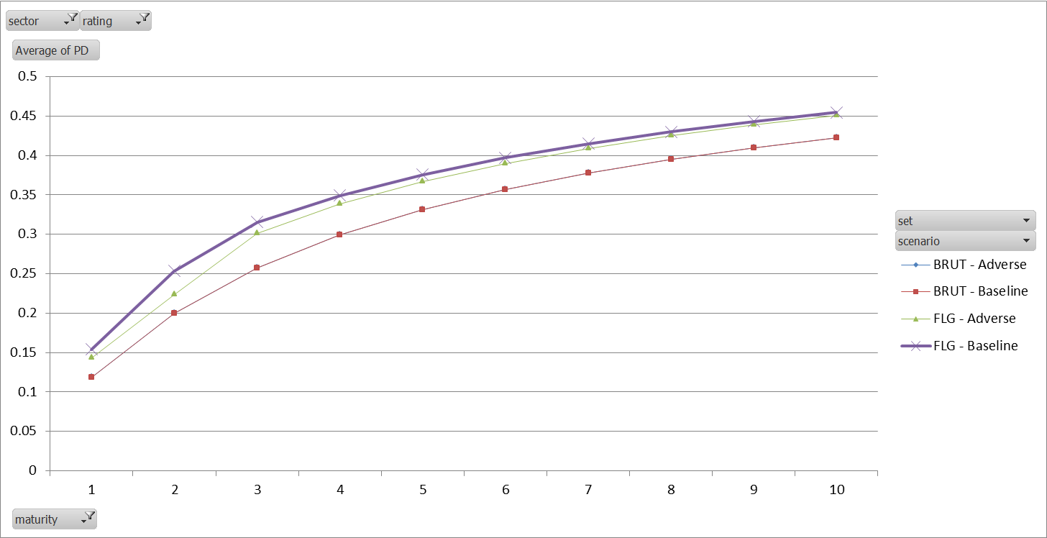

Figure 9: Example of TTC and Forward Looking Corporate PD term structure, rating E-.

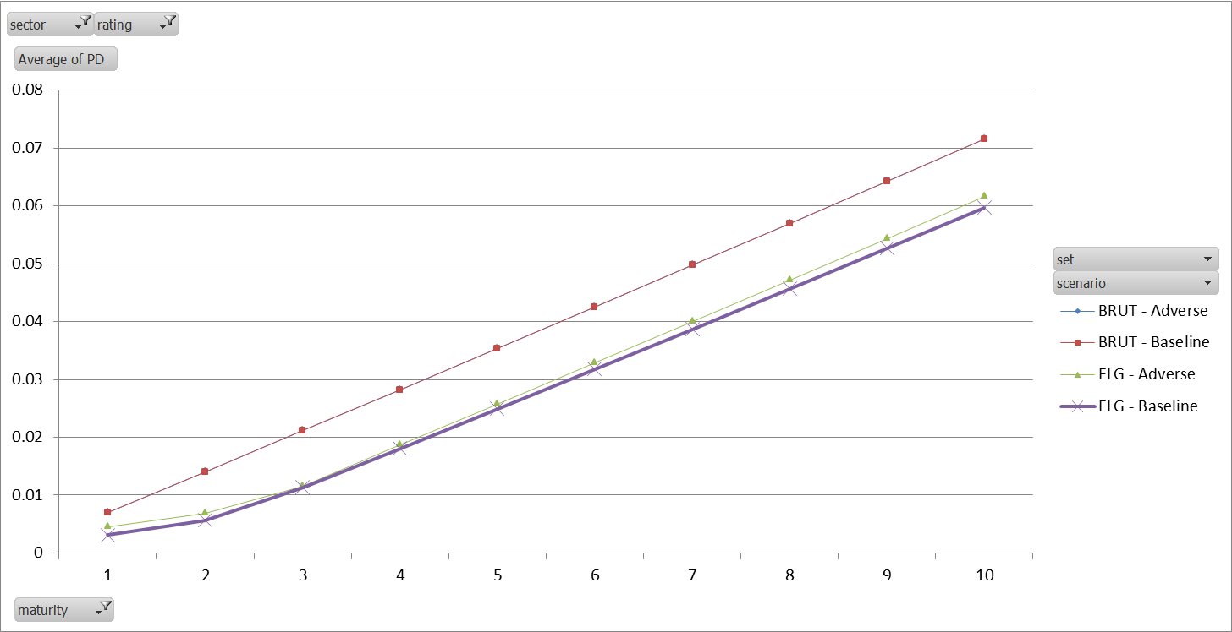

Figure 10: Example of TTC and Forward Looking FI PD term structure, rating C-.

## LGD term structure

Figure 9 shows an example of forward looking LGD. The impact on the LGD is similar to the dynamic of the projected default systemic index (see Figure 10). The extrapolation is immediate to the TTC level.

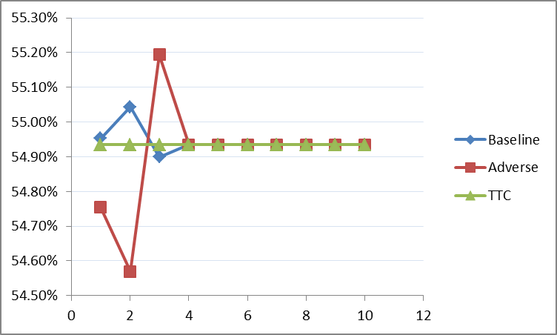

Figure 11: Example of Forward looking LGD corporate unsecured result. Segment (Zone 3, CA<300M, Filiere Other)

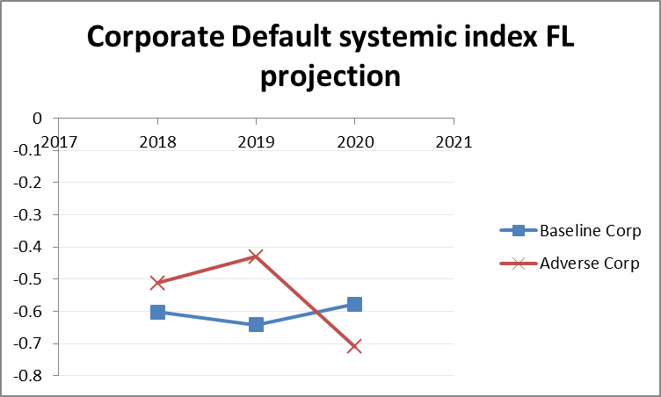

Figure 12: Default systemic index forward looking projection

# Multiple scenarios calculation

IFRS 9 standards require a multiple scenario calculation in order to correctly measure the convexity effect in the expected credit loss. 4 scenarios are projected according to the group methodology requirements (Baseline, Adverse, Favorable and stress budgetaire).

CASA ECO delivers the projection of macroeconomic variables. They are transformed to a projection on the systemic variable couple $\left(Z^{D}, Z^{M}\right)$ through the Projection Model.

The used default probability is the weighted average default probability over each scenario.

The used LGD is the weighted average LGD over each scenario.

Weights are given by CASA ECO for each macroeconomic scenario.

# Bibliography

|  |  |
| --- | --- |
| [1] | W. V. G. C. T. V. G. D. M. A. B. B. KOEN BERTELOOT, "A Novel Credit Rating Migration Modeling Approach Using Macroeconomic Indicators," *Journal of Forecasting,* pp. 654-672, 2013. |
| [2] | N. D. V. M. D. M. Olivier de Bandt, "Stress-testing banks’ corporate credit portfolio," Direction des Études - SGACP - Débats économiques et financiers N°2, 2013. |
| [3] | R. Violi, "Credit Ratings Transition in Structured Finance," *Journal of Financial Transformation, No. 22, June 2008,* 2007. |
| [4] | T. S. Yusuf Jafry, "Metrics for Comparing Credit Migration Matrices," *Wharton Financial Institutions Center Working Paper No. 03-09,* 2003. |
| [5] | T. S. Yusuf Jafry, "Measurement, estimation and comparison of credit migration matrices," *Journal of Banking & Finance,* pp. 2603-2639, 2004. |
| [6] | Basel Committee on Banking Supervision , "An Explanatory Note on the Basel II IRB Risk Weight Functions," 2005. |

1. Note that, for IFRS 9 purposes the matrix used for extrapolation further than 4 years are TTC matrices. Whereas for Stress purposes, the matrix used is the baseline matrix. This is due for two reasons:

   IFRS 9 and stress frameworks are not required to be aligned. MRP/MQP does the best effort to align them in order to produce coherent risk measures.

   According to the Credit Agricole Group IFRS 9 norm, the extrapolation has to be done by reverting to the mean parameters. This is why a TTC matrix is used. However, according to STAMP€ from EBA, the extrapolation has to be one by reverting to the baseline parameters.
2. Average difference by Rating
3.